Physical Fitness Test Reference Guide
Updated March 2024

Table of Contents

Section 1 Introduction and Overview 3
FitnessGram® 4
Administration Information 4
Testing Students with Disabilities 5
Section 2 Components and Tests 6
Aerobic Capacity 7
Administration Tips for the Aerobic Capacity Tests 7
One-Mile Run or One-Mile Walk 7
20m PACER 8
Muscle Strength, Endurance, and Flexibility 9
Curl-Up 9
Trunk Lift 10
Push-Up 11
Modified Pull-Up 12
Flexed-Arm Hang 12
Flexibility 13
Back-Saver Sit and Reach 13
Shoulder Stretch 14

Section 1
Introduction and Overview
This reference guide is designed to assist local educational agency (LEA) staff in becoming familiar with the California Physical Fitness Test (PFT). The PFT is a comprehensive, health-related battery of physical fitness tests for students in California.
This guide includes a detailed description of each component tested and suggestions for facilitating the administration of each test.
Please note that this guide is not designed as a replacement for the FitnessGram/ActivityGram® Test Administration Manual. More information about the FitnessGram Assessment can be found on the Cooper Institute Health-related fitness components web page at https://www.cooperinstitute.org/youth/fitnessgram.
California Education Code (EC) Section 60800 requires all LEAs to administer the PFT annually, between February 1 and May 31, to public school students in grades five, seven, and nine. LEAs may request a California State Board of Education (SBE) waiver to administer the PFT outside the designated testing window. Students are required to take the PFT whether or not they are enrolled in a physical education (PE) class or participate in a block schedule.

FitnessGram
The SBE designated the FitnessGram as the PFT for students in California public schools. The FitnessGram is designed to assess two main categories of fitness: (1) aerobic capacity, and (2) musculoskeletal fitness. It is composed of the following five key components:
- Aerobic Capacity
- Abdominal Strength and Endurance
- Trunk Extensor Strength and Flexibility
- Upper Body Strength and Endurance
- Flexibility
A level of fitness in these five components offers a degree of defense against diseases that are associated with inactivity. The test results can be used by students, teachers, parents, and guardians to monitor overall fitness and evaluate their LEA's PE program.

Administration Information
Most of the FitnessGram tests can be administered in a space equivalent to the size of most classrooms. The test options for Aerobic Capacity require the greatest amount of space. One of these options, the Progressive Aerobic Cardiovascular Endurance Run (PACER), requires a space that can accommodate the 15- or 20-meter distance needed to carry out the test. Schools with limited space may consider using one of the following options:
- Classroom, lunchroom, auditorium, or other similar spaces
- PE facility on another school campus
Local Park and Recreation facility LEAs should review their confidentiality practices to make sure that appropriate protocols are in place to ensure as much privacy as possible to safeguard PFT results from students other than the one being tested. In addition, LEAs should develop a receptive process to ensure the safety and concerns of their students and students’ parents or guardians by being sensitive to such variables as preexisting special needs and maturation stage of the students.

Testing Students with Disabilities
Certain variations or accommodations may be provided for students with disabilities who need special assistance on the PFT.
Most of the components of the FitnessGram provide two or three test options, so most students, including those with disabilities, have the opportunity to participate in the PFT. All students with disabilities who are unable to take the entire PFT should be given as much of the test as each student’s physical condition permits.
Please consult with the student's individualized education program or Section 504 plan for their allowed modifications for PE and apply them to the PFT.

Section 2
Components and Tests

Aerobic Capacity
Three test options are provided under the Aerobic Capacity component:
- One-Mile Run or One-Mile Walk
- 20-Meter Progressive Aerobic Cardiovascular Endurance Run (20m PACER)

Administration Tips for the Aerobic Capacity Tests
- Practice pacing and techniques for heart rate monitoring.
- Allow students adequate time to warm up and cool down.
- To avoid potential health and safety issues, do not administer a test in unusually high temperatures or humidity or when the wind is strong.

One-Mile Run or One-Mile Walk
The One-Mile Run and One-Mile Walk estimate aerobic capacity. Students are instructed to run a mile as fast as they are able. Walking is permitted for students who cannot run the total distance. The time taken to complete the run or walk is recorded in minutes and seconds.
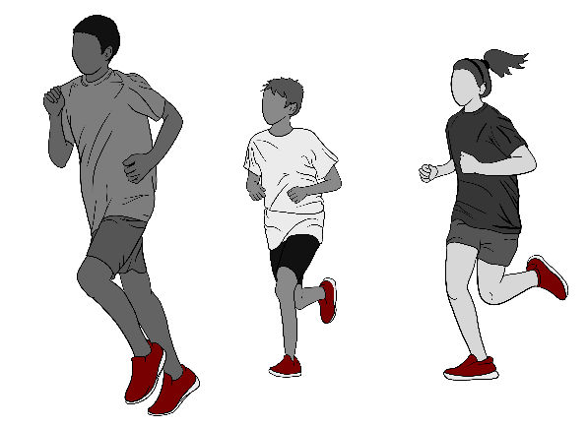
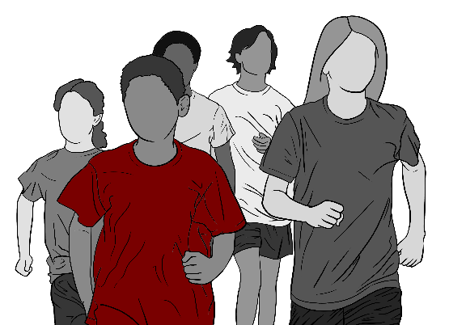

20m PACER
The 20m PACER estimates aerobic capacity from the number of laps (20 meters in distance) that are completed. Unlike the other two Aerobic Capacity options, the PACER starts out easy and becomes progressively more difficult.
For this test, a pair of parallel lines are drawn 20 meters apart. Students start on one line, run the distance, and touch the opposite line with one foot. Once they hear the sound of a single beep, students turn around and run back to the starting line. Every minute, as indicated by a triple beep, the pace gets faster. Students continue in this manner until they fail twice to touch the line before they hear the beep. Additional guidelines for administering the PACER are as follows:
- In the proper administration of the PACER, a student is allowed two form breaks with the first form break counting as a lap. A student who commits two form breaks after the start of the PACER should be scored as completing one lap.
- If the 15-meter PACER (15m PACER) is administered, the 15m PACER laps first need to be converted to 20m laps. The PACER Conversion Chart is located in the FitnessGram Test Administration Manual.
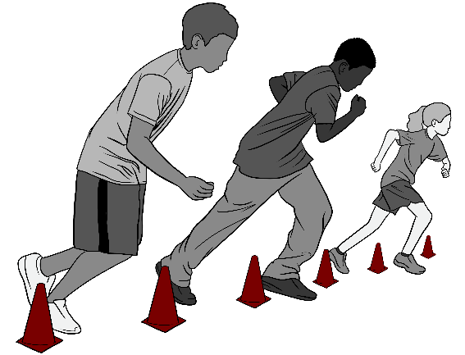

Muscle Strength, Endurance, and Flexibility
The Muscle Strength, Endurance, and Flexibility component determines the health status of the musculoskeletal system. Balanced, healthy functioning of this system requires that muscles work forcefully over a period of time and be flexible enough to have a full range of motion at the joints.
To determine the health level of the musculoskeletal system, three major components are tested:
- Abdominal Strength and Endurance
- Trunk Extensor Strength and Flexibility
- Strength and Endurance
One test option is provided under the Abdominal Strength and Endurance component—the Curl-Up.

Curl-Up
Students are to complete as many Curl-Ups as they are able (up to a maximum of 75) at a specified pace of about one Curl-Up every three seconds. The pace should be called or played on a prerecorded tape or CD.
On a mat, students lie on their back with their knees bent, feet flat on the mat, and their hands at their sides, palms down. Moving slowly, students curl up, sliding their fingers across a measuring strip on the mat, and then curl back down until their head touches the mat. Students are directed to stop either after reaching a count of 75 Curl-Ups, when the second form break occurs, or at four minutes’ time.
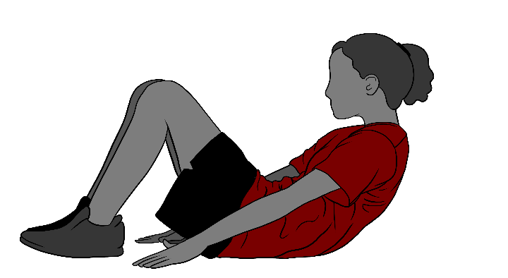

Administration Tips for the Curl-Up Test
- Allow students to learn and practice the correct Curl-Up form.
- Curl-Up movements should be rhythmic (i.e., with the cadence) and continuous.
- Pauses and rest periods are not allowed.
- Students should reposition themselves if their body moves and their head does not contact the mat at the appropriate spot, or the measuring strip moves out of position.
Additional scoring rules for the Curl-Up: In the proper administration of the Curl-Up, a student is allowed two form breaks, with the first form break counting as a repetition. A student who commits two form breaks after the start of the Curl-Up should be scored as having completed one repetition.
One test option is provided under the Trunk Extensor Strength and Flexibility component—the Trunk Lift. The Trunk Extensor Strength and Flexibility component is an important component of fitness because it predicts first-time and recurrent lower back pain—a major source of disability and discomfort in the United States. Although risks of developing back pain are greater with age, awareness and attention to trunk musculature at an early age are important to reduce future risks.

Trunk Lift
While lying face down on a flat surface, students are asked to slowly lift their upper body off the floor, using the muscles of the back, to a maximum of 12 inches. Students need to hold the position for measurement (i.e., distance from the floor to the student’s chin), which is recorded in whole inches only. During the test, students should be instructed to keep their eyes focused on a spot on the floor. Once the measurement is made, the student returns to the starting position. A second trial is conducted, and the highest score is recorded.
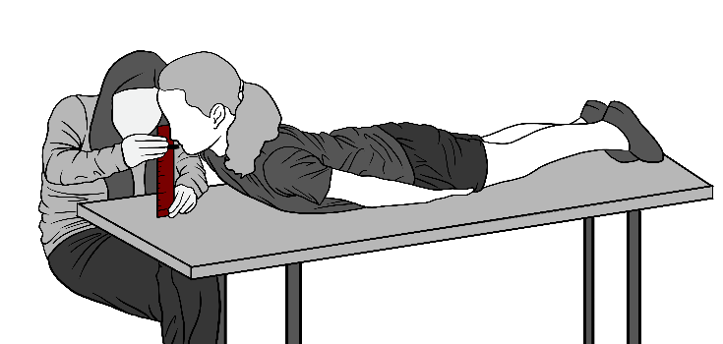

Administration Tips for the Trunk Lift Test
- Students should not bounce during the test.
- Providing a spot on the floor for the student to focus on should assist the students in maintaining the proper head position.
- As a safety precaution, students should not be encouraged to lift higher than
12 inches; this is because excessive arching of the back may cause harm by compressing the intervertebral discs.
The Upper Body Strength and Endurance component is important in that it contributes to the maintenance of functional health and good posture. Three test options are provided under this component:
- Push-Up
- Modified Pull-Up
- Flexed-Arm Hang

Push-Up
Students are instructed to complete as many 90-degree Push-Ups as possible at a specified pace (of about one push-up every three seconds), up to a maximum of 75. The pace should be called or played on a prerecorded CD.
Students are directed to stop either after reaching a count of 75 Push-Ups, when the second form break occurs, at four minutes' time, or when they experience extreme discomfort.
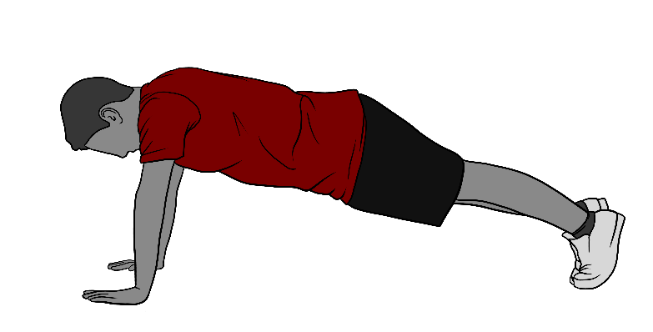

Administration Tips for the Push-Up Test
- Allow students to learn and practice the correct Push-Up form.
- All genders follow the same protocol.
Additional guidance for administering the Push-Up Test: In the proper administration of the Push-Up, a student is allowed two form breaks, with the first form break counting as a repetition. A student who commits two form breaks after the start of the Push-Up should be scored as having completed one Push-Up.

Modified Pull-Up
Students are instructed to successfully complete as many Modified Pull-Ups as they are able. Students perform the Modified Pull-Up by lying on their back directly under a bar. Students grasp the bar and pull up their upper body until their chin reaches a specified level, marked by an elastic band. Students are directed to stop when the second form break occurs. The number of Modified Pull-Ups is recorded.
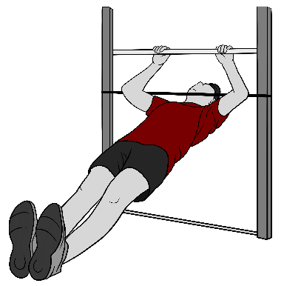

Administration Tips for the Modified Pull-Up Test
- Only arm movement is allowed; the body should be kept straight.
- Movement should be rhythmic and continuous.
- Students may not stop to rest.
Additional guidance for administering the Modified Pull-Up Test: In the proper administration of the Modified Pull-Up, a student is allowed two form breaks, with the first form break counting as a repetition. A student who commits two form breaks after the start of the Modified Pull-Up should be scored as having completed one Modified Pull-Up.

Flexed-Arm Hang
For the Flexed-Arm Hang, students are instructed to hang with their chin above a bar as long as they are able, grasping the bar with an overhand grip or palms facing away from the body. Students are stopped when their chin drops below the bar or when a form break occurs.
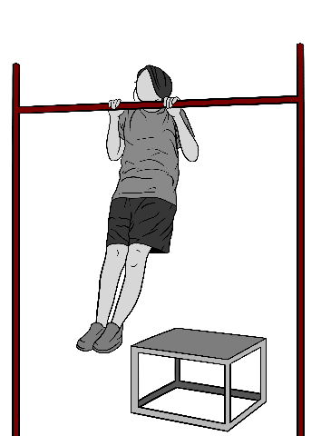

Administration Tips for the Flexed-Arm Hang Test
- The body should not swing during the test.
- Only one trial is permitted unless the examiner believes that the student has not had a fair opportunity to perform one trial.

Flexibility
Flexibility—of the joints, both in the upper and lower body—is an important component of health-related fitness. People benefit from increased flexibility on a daily basis, both in routine tasks and those associated with more rigorous physical activity.
Two test options are provided under the Flexibility component:
- Back-Saver Sit and Reach
- Shoulder Stretch

Back-Saver Sit and Reach
The Back-Saver Sit and Reach predominantly measures the flexibility of the hamstring muscles. Students are instructed to reach the specified distance on the left and right sides of the body. Starting in a sitting position, with the left leg extended (the foot is flat against the front side of the box needed for this test) and the right leg bent, the student reaches forward with both hands along the scale printed on the box.
Students reach four times and hold the position on the fourth reach for at least one second. The distance of the reach is recorded to the nearest inch and to a maximum of 12 inches. To measure reach distance with the other side of the body, the same procedure is repeated, with the extended and bent legs switched. The scores are recorded separately for the two sides of the body.
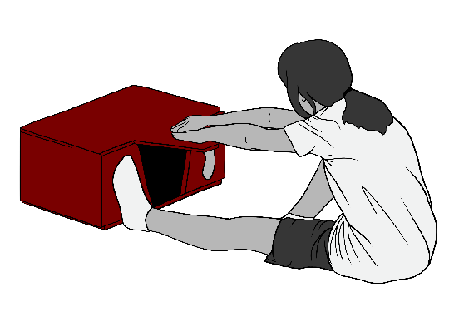

Administration Tips for the Back-Saver Sit and Reach Test
- The knee of the extended leg should remain straight.
- Hips must remain square to the box. Do not allow the student to turn the hip away from the box as the student reaches.

Shoulder Stretch
The Shoulder Stretch measures upper body flexibility. Students are instructed to touch the fingertips together behind the back with one hand reaching over the shoulder and the other under the elbow.
Additional guidance for administering the Shoulder Stretch: Both shoulders are tested, and the score for each is recorded separately.
